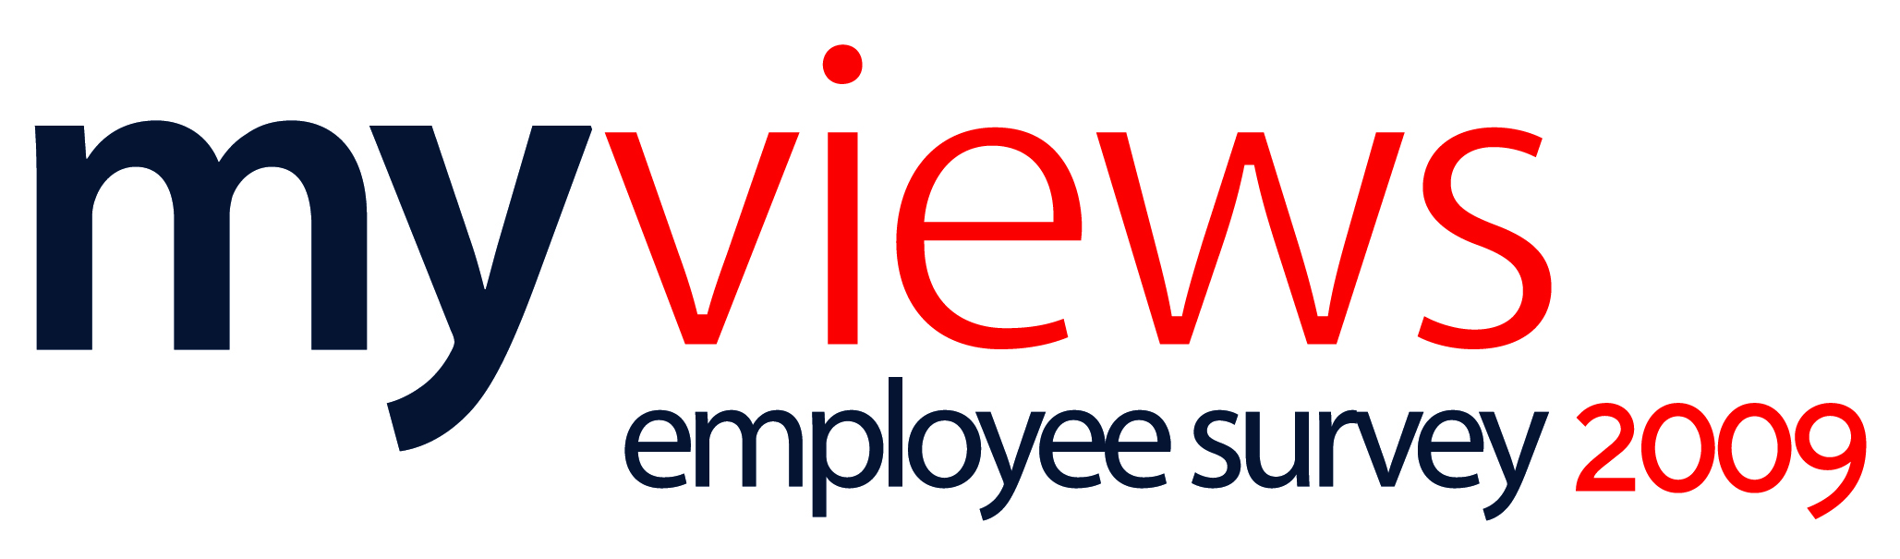

In September I wrote to you with the good news that our recent ‘MyViews’ employee survey had achieved an excellent response rate across the Group of 68%. At this time I committed to sharing the results of the survey with you and what we planned to do to address the issues identified. Here is a summary of the results:

Our Top 10 Results
Questions with the most positive response | % Positive Score | % Negative Score
I care about the future of Scapa | 90% | 2%
I understand how the work I do helps Scapa achieve its aims | 88% | 3%
I am clear about what I am expected to achieve in my job | 85% | 5%
I have the knowledge and skills I need to do my job | 85% | 4%
I understand the meaning of the new Scapa Vision | 82% | 5%
I am proud of the work I do | 81% | 4%
I understand the aims and objectives of Scapa | 81% | 6%
I enjoy my work | 80% | 5%
I would still like to be working at Scapa in two years time | 78% | 5%
I know what I am expected to do to support the company to achieve our vision | 76% | 6%

Our Bottom 10 Results
Questions with the most negative response | % Positive Score | % Negative Score
My pay is linked to my performance and contribution | 26% | 48%
In the last week I have received thanks or praise for doing good work | 37% | 42%
Remuneration compares favourably with other employers | 28% | 37%
My manager takes time to coach me and develop my skills | 36% | 35%
Company wide communication is good | 40% | 33%
My Line Manager gives me regular feedback on how I am doing | 42% | 31%
I feel valued and recognised for the work I do | 46% | 30%
I have received the training and development I need to develop in my career at Scapa | 41% | 28%
Benefits compare favourably with other employers | 39% | 27%
My career development aspirations at Scapa are being met | 38% | 26%

Our Vision & Values
A key objective of our employee survey was to test how well the new Vision had been understood across our business. Our results show that there is both a high level of understanding of what it means and what individuals within the business need to do to support the achievement of the Vision.

 | % Positive Score | % Negative Score
I understand the meaning of the new Scapa Vision | 82% | 6%
I know what I am expected to do to support the company to achieve our vision | 76% | 6%
I believe that Scapa operate according to the company values | 53% | 18%

Differences by Site
In this section of the summary report we outline some of the differences in the responses between our sites on the basis of goal clarity, employee involvement and teamwork.

Further details of the demographic differences both by site, job role, function and length of service can be found in the full reports.

- Goal Clarity
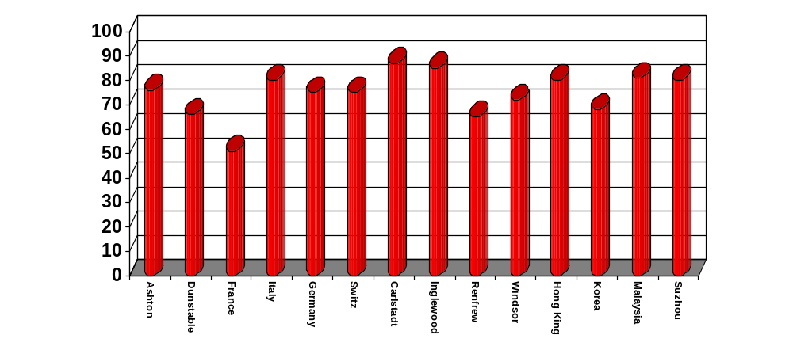

- 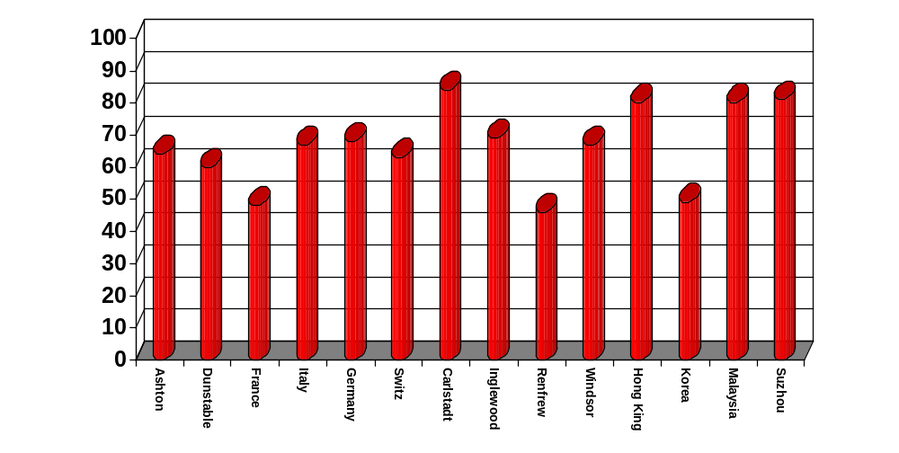Employee Involvement

- 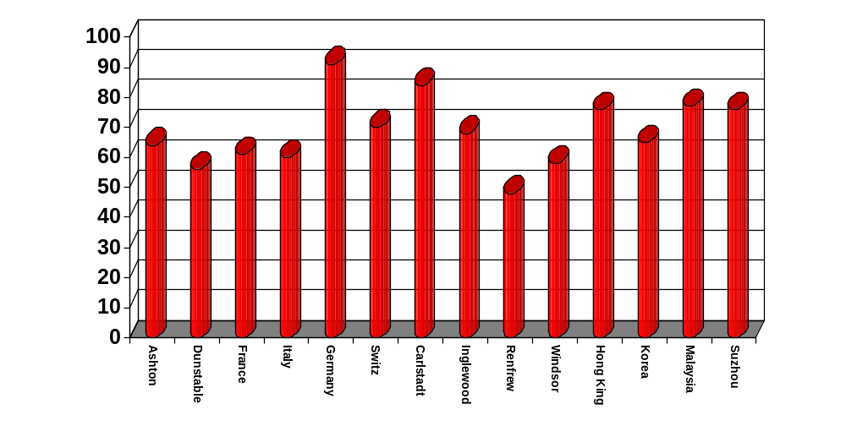Teamwork

Benchmarking
Our results have been compared to all other organisations held on the People Insight database and below are the areas where we have scored 10% above and below the benchmark average:

Performance at least 10% better than the benchmark average:

- I would like to be working at Scapa in 2 years time

Performance greater than 10% lower than the benchmark average:
- People in my immediate team work well together
- Morale in my immediate team is generally high
- In the last week I have received thanks or praise for doing good work
- I feel valued and recognised for the work that I do
- My Line Manager shows appreciation for the work I do
- My Line Manager treats people fairly and with respect
- My Line Manager gives me regular feedback on how I am doing

Areas Identified for Action & What Next?
The results identify four areas where we should seek to focus our efforts in order to make improvements in employee engagement and satisfaction. These areas are:
- Line Management Communications
- Employee Pay and Recognition
- Company Wide Communications
- Training & Development

So what happens next? The full survey results have now been published on the intranet site. If you do not have access to the intranet and would like to see the full reports please contact your line manager in the first instance.

In terms of improvement actions we are looking to enhance training/career development opportunities for all staff and over the coming months you should start to see some improvements in Line Management communications as all senior management progress through the Management Essentials training programme designed to address areas of development for some of our managers.

I also hope that you have started to see that we are making some advances as an organisation in how we manage cross company communications. We have more planned including an immediate action to introduce a regular business update.

I have also asked each of our site managers to analyse the output of the survey for their site and to develop some local actions they can take. They will be communicating what they will be doing on a local level very soon.

The input you have provided has been very useful in helping us to prioritise our efforts and I would like to thank you all once again for all your involvement and also your continued hard work and efforts on behalf of Scapa.

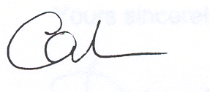
Calvin O'Connor
Chief Executive

